Module 4)
CSS and CSS 3
Q 1}What are the benefits of using CSS?
Ans: CSS stands for Cascading Style Sheets. CSS is used to give a style to HTML. CSS is very important in HTML. Without CSS you can’t make a attractive and beautiful website. CSS is used to give a color , font style, image, different text , space and much more.
CSS is also used to make a website responsive. Css is easy to maintain. We can also use a Animation and Effects in CSS. Also with the use of External css file can easily used in multiple pages.
If you want to change some pages in css simply change the css file and it will change your content easily.
Syntax of CSS:-
Selector{ property: value; }
Example:-
h1 { color: red ; font-size: 2 px; }
Output:-
It gives h1 text color red and font size 2 px.
Q 2}What are the disadvantages of CSS?
Ans: If We using css there are some Disadvantages to using CSS.
If we using css in any browser and show that same output in other browser it will change all the layout in other browser , This is disadvantage in CSS.
Also some syntax in CSS is quite complicated.
There are also a levels in CSS like
CSS1 CSS2
CSS3
That 3 levels have some differences , That’s why CSS create confusion for learners.
CSS is also a large file size. CSS file cover large size.
Q 3}What is the difference between CSS2 and CSS3?
Ans:
CSS2:
CSS2 have a Single Document.
CSS2 have a more features comparing to CSS.
CSS2 have a simple selectors.
CSS2 can not make a Rounded Borders.
CSS2 not have split text.
In CSS2 you can not create a grid .
It have also a Web-safe fonts.
CSS3:
CSS3 have a Individual Modules.
CSS3 supports Animations.
It has a Sequence of simple selectors.
CSS3 can make a Rounded Borders.
CSS3 have split text.
In CSS3 you can create a grid . CSS3 have a Google Fonts.
Q 4}Name a few CSS style components Ans: Following is the CSS style components.
1.Selectors
2.Flexbox
3.Grid
4.Media Queries
- Animation
- Position
7.Boxmodel
Q 5} What do you understand by CSS opacity? Ans: CSS is a very important Property .
It is used to create a blur image.
CSS gives a transparency to items.
If you want to make a image blur give a opacity property to your CSS.
It makes a transparent image.
Example:-
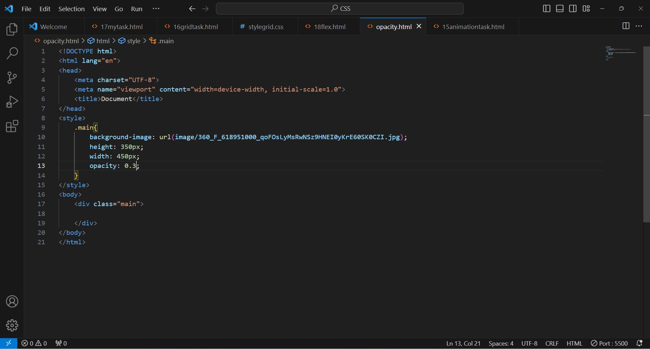
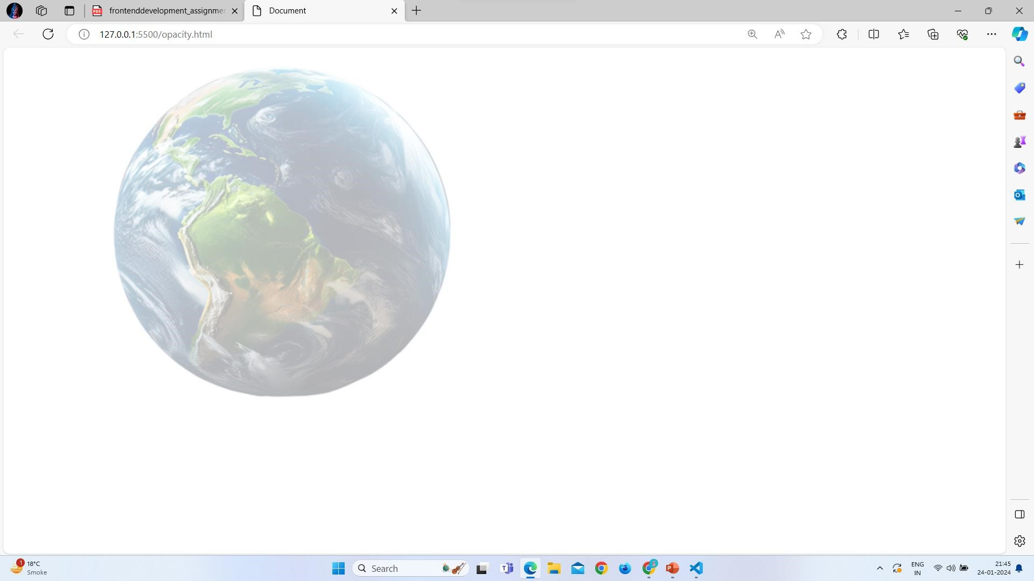
Q 6}How can the background color of an element be changed?
Ans: We can change the background color of an element. We can give the background color of an element of any. There are the property which is background-color it will change the color of background of element.
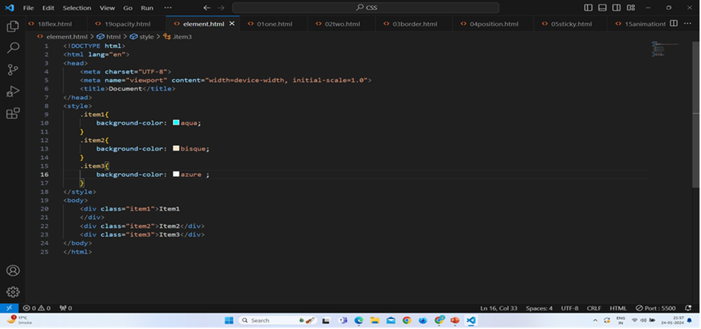
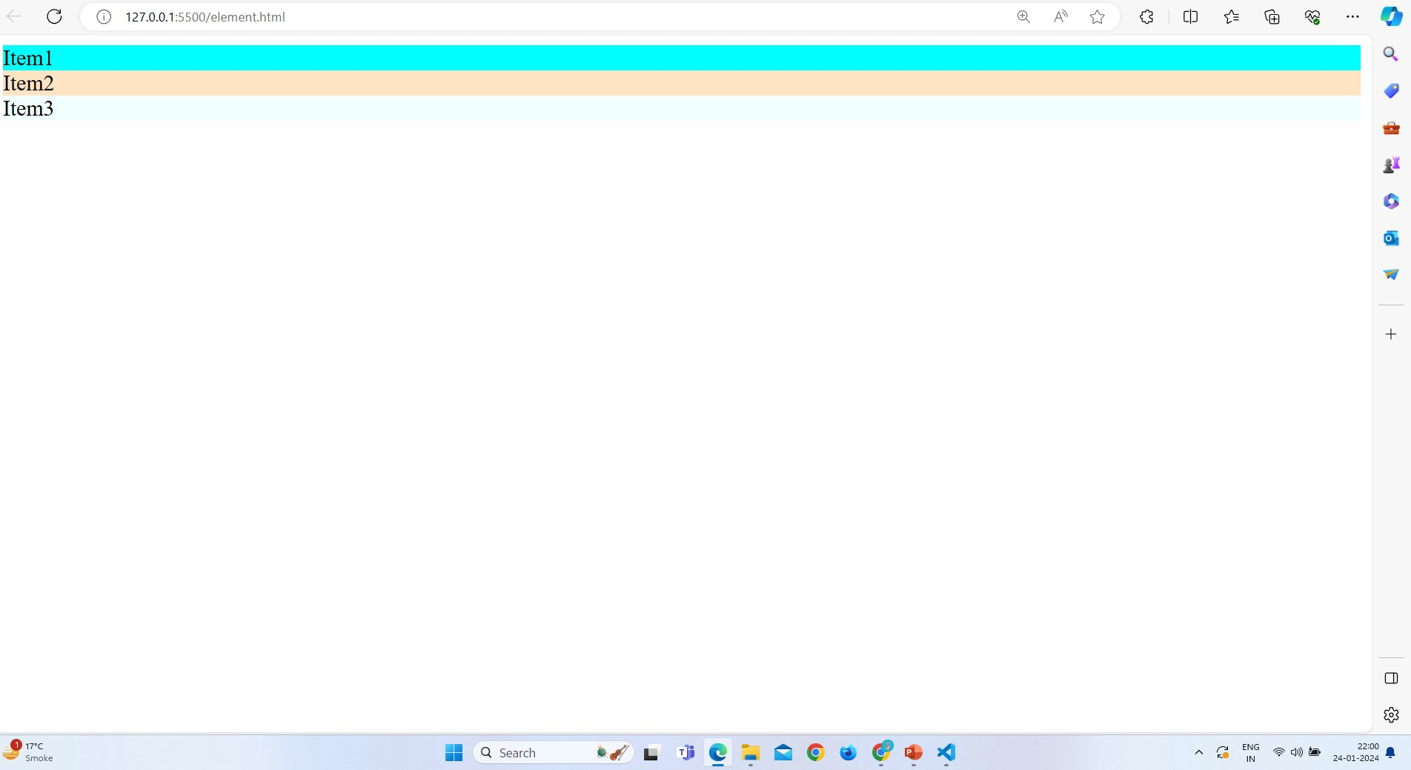
Q 7}How can image repetition of the backup be controlled?
Ans: If there are the image and that will repeat in that condition there are many property to control the repeat image.That was background-repeat : repeat| repeat- x | repeat- y | no- repeat
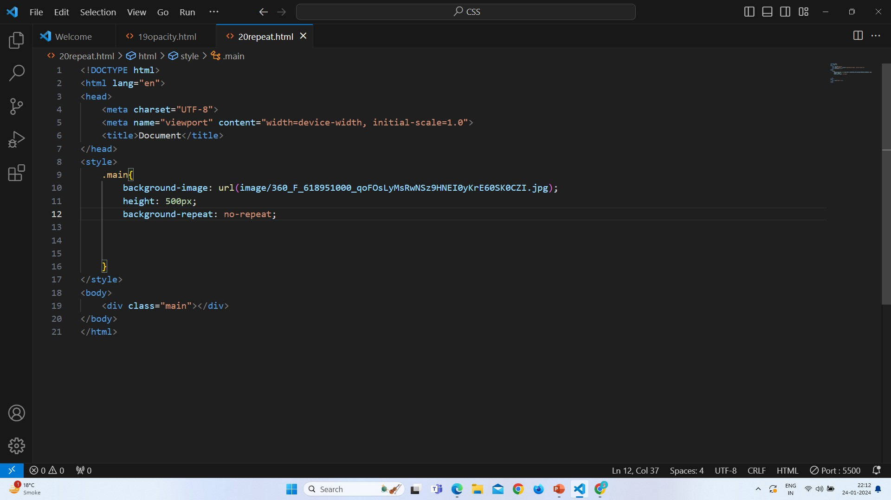
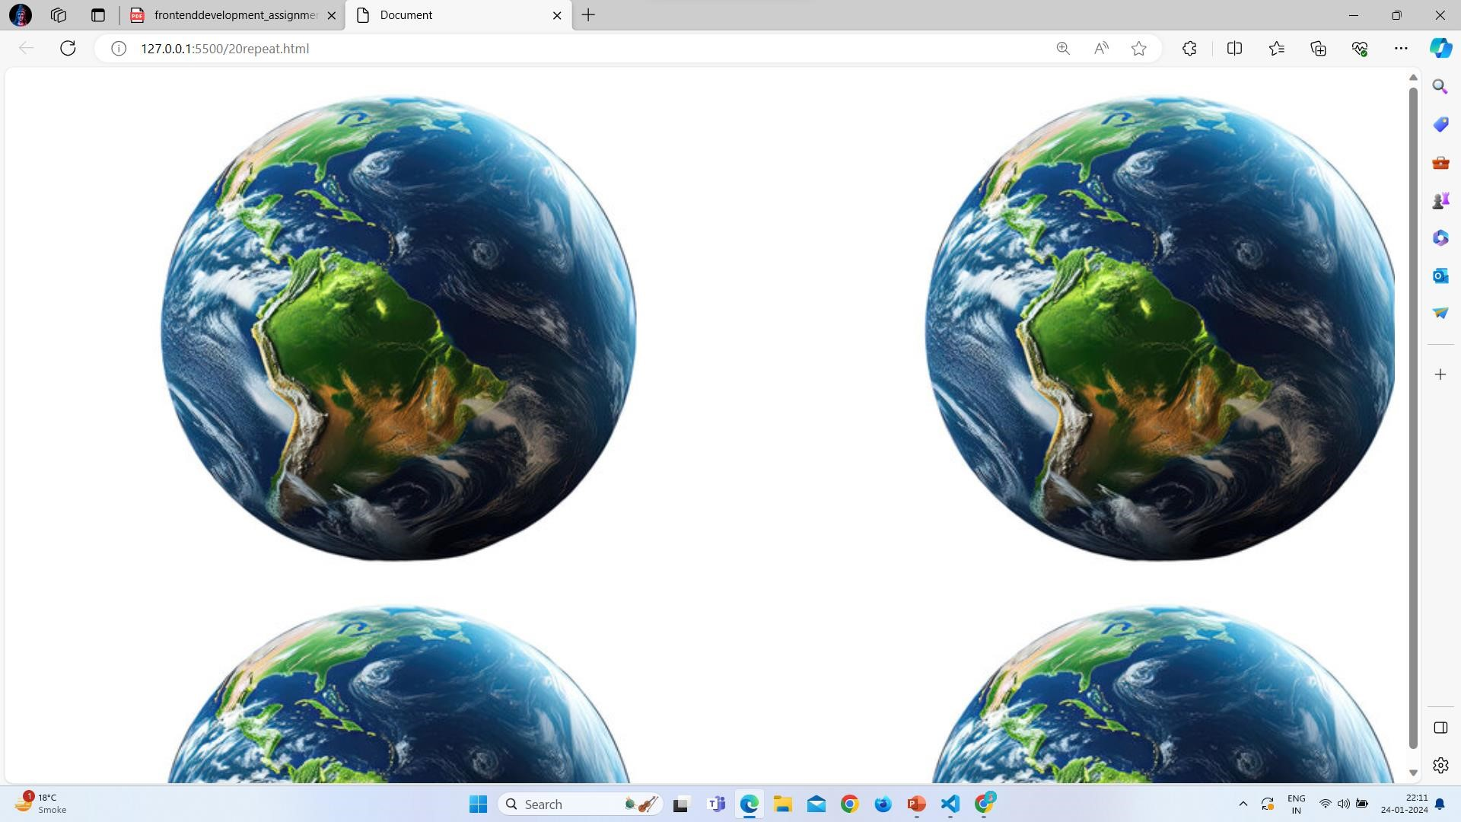
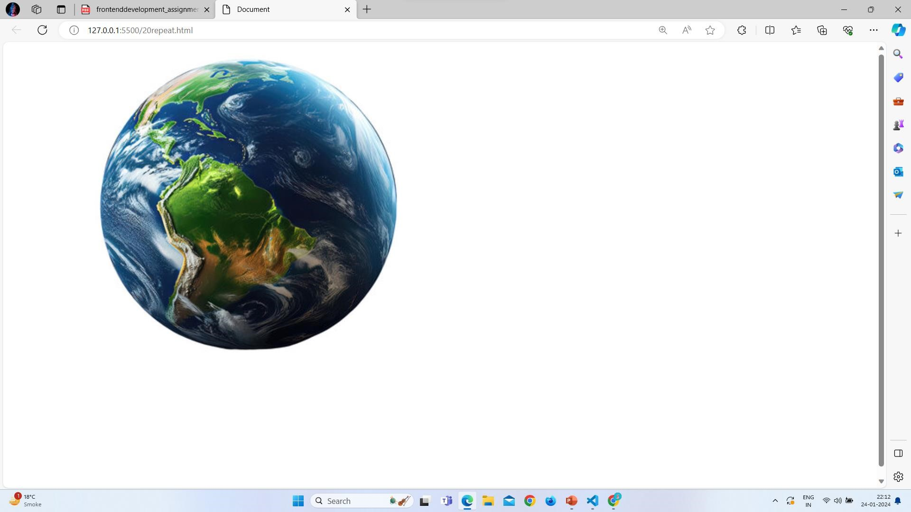
Q 8} What is the use of the background-position property?
Ans: Background-position property gives the position to items .In it we can give a background-position any what you want.

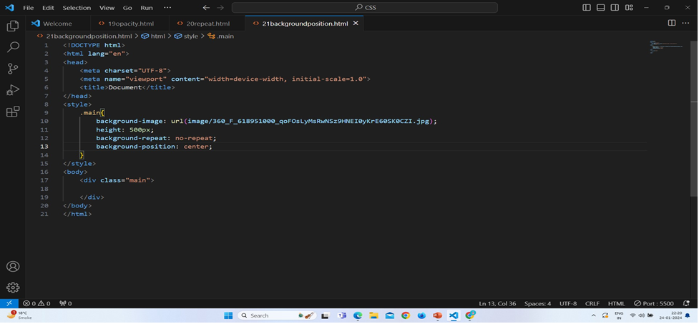
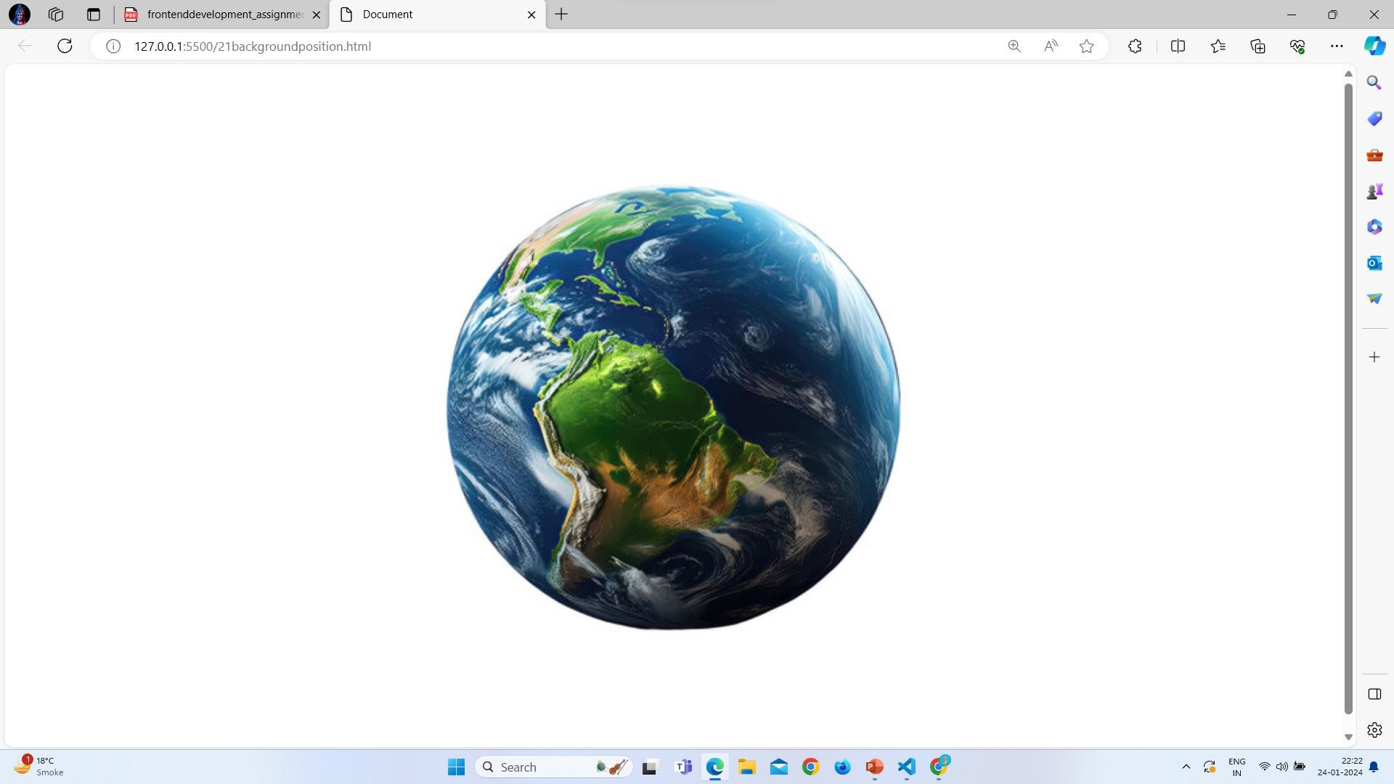
Q 9}Which property controls the image scroll in the background?
Ans: In the image you don’t want to scroll image there will a property that you can use in your web page.That was background-attachment : scroll , fixed , local , initial , inherit
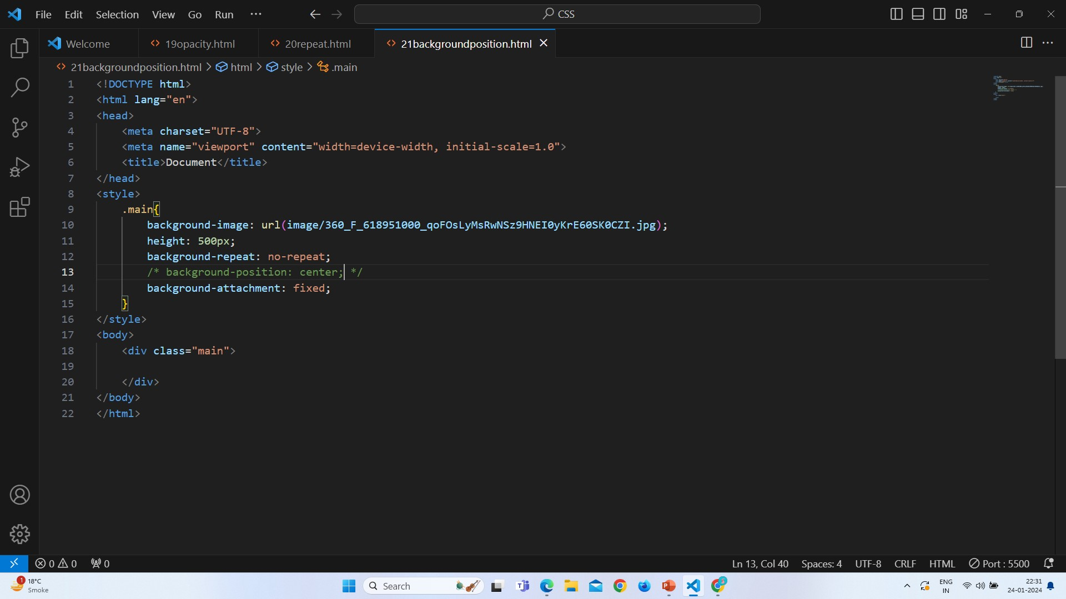
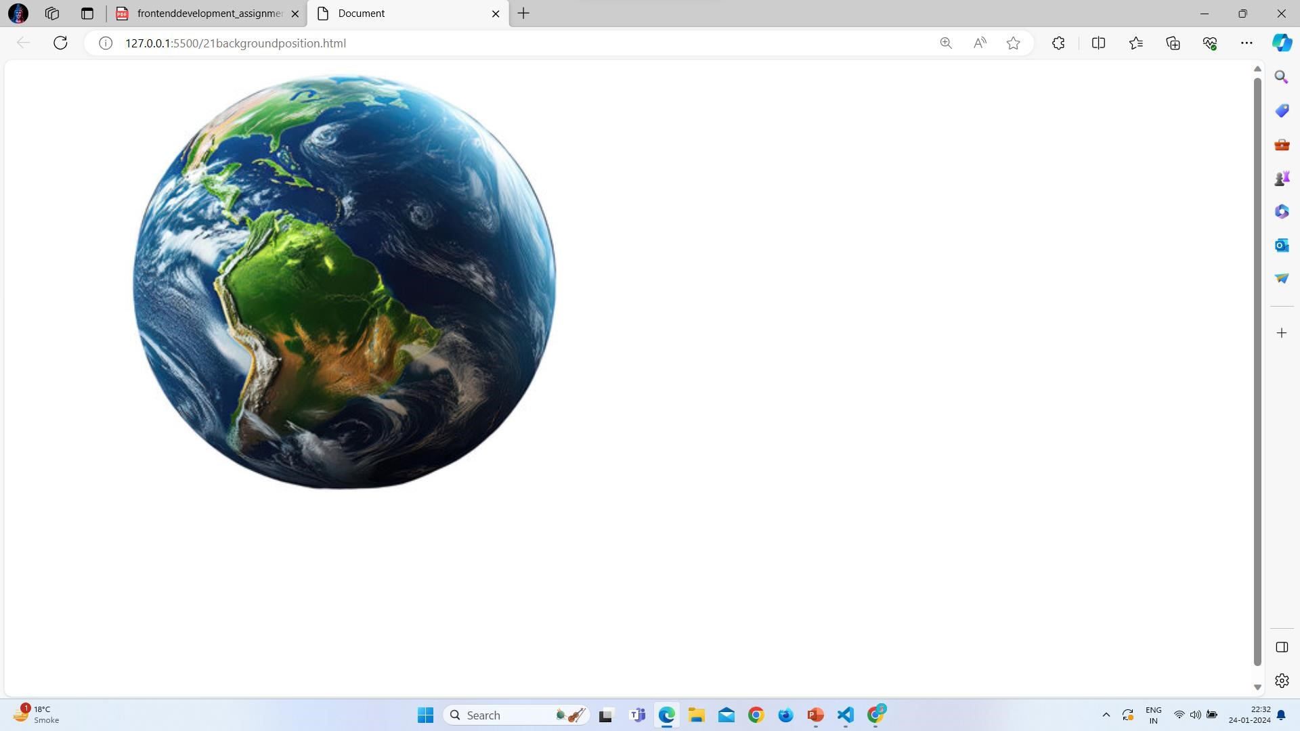
Q 10}Why should background and color be used as separate properties?
Ans: background and color ne used as separate properties because both have a different purpose.

Background is used to give a color to background in page , to using of background property you can add a color to your background .

Color property is used to give a color to text , using of color property you can change the text color.

Example:-
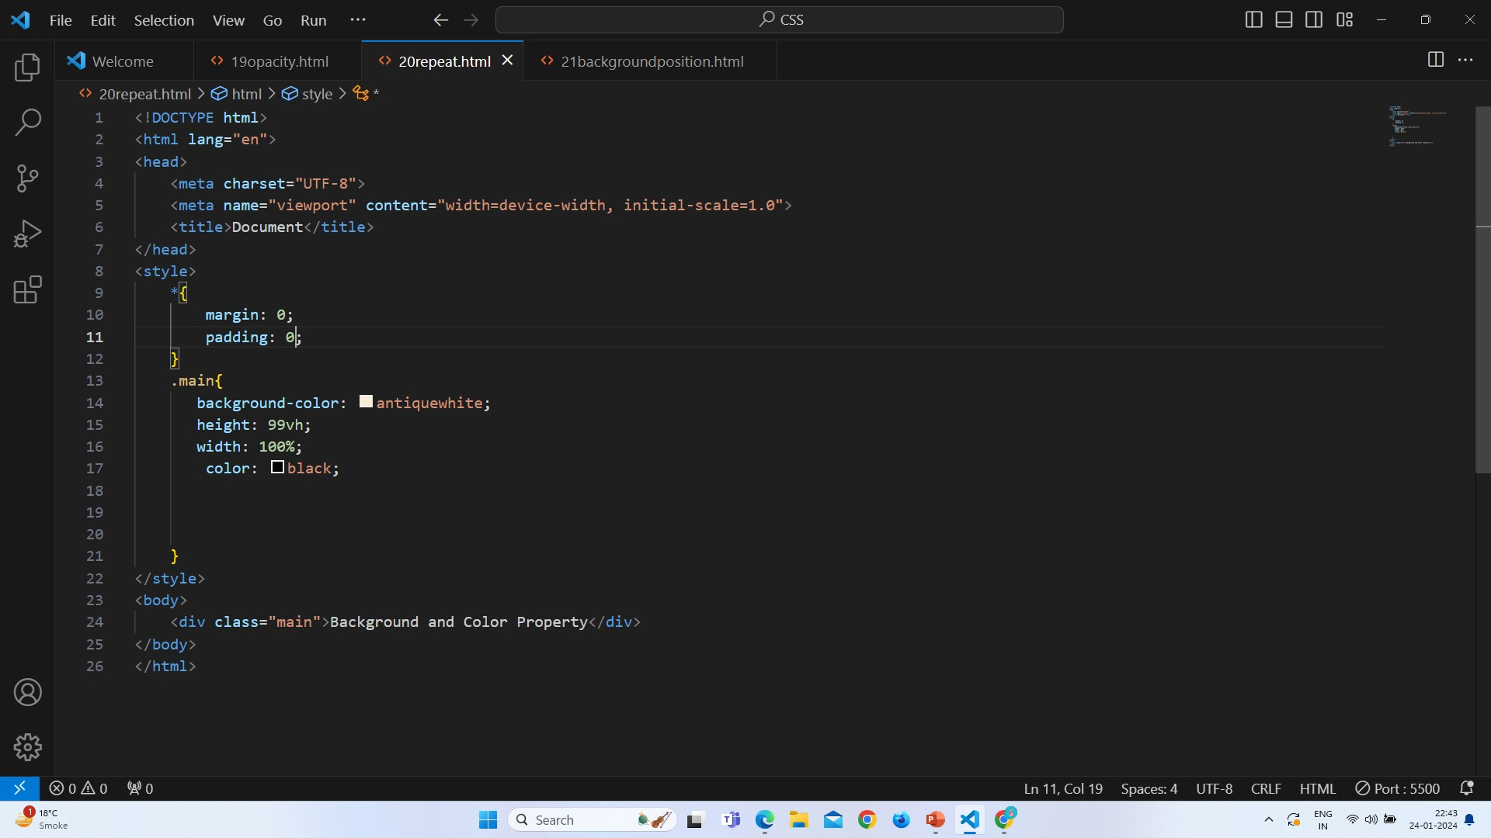
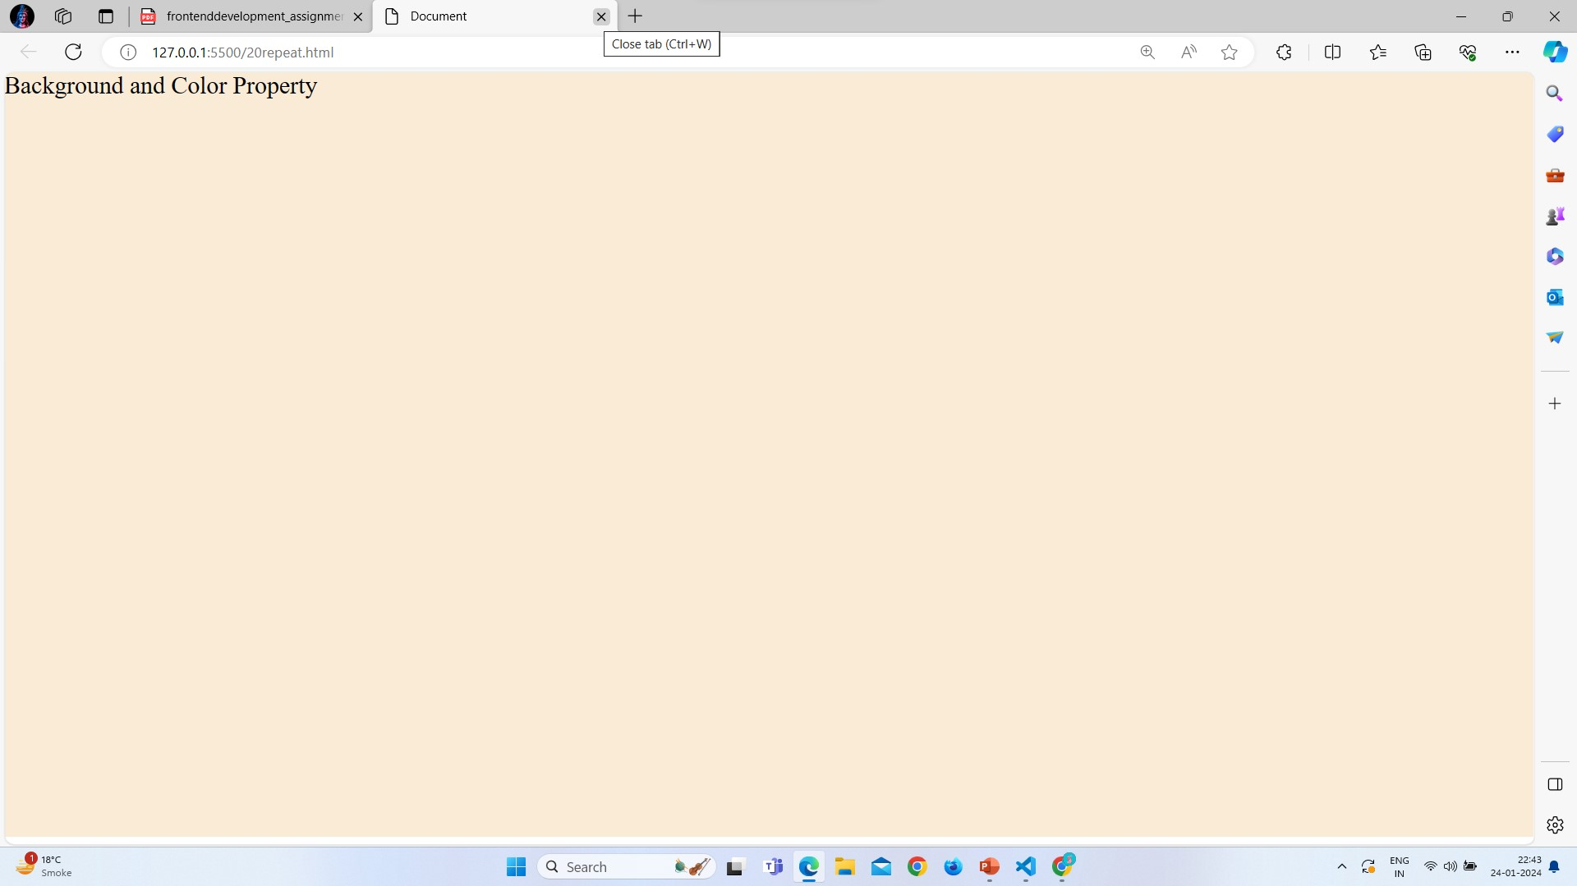
Q 11} How to center block elements using CSS1?
Ans: To center a block elements using CSS1 you can use the property which was text- align : center;With the help of this property you can center the text in css.
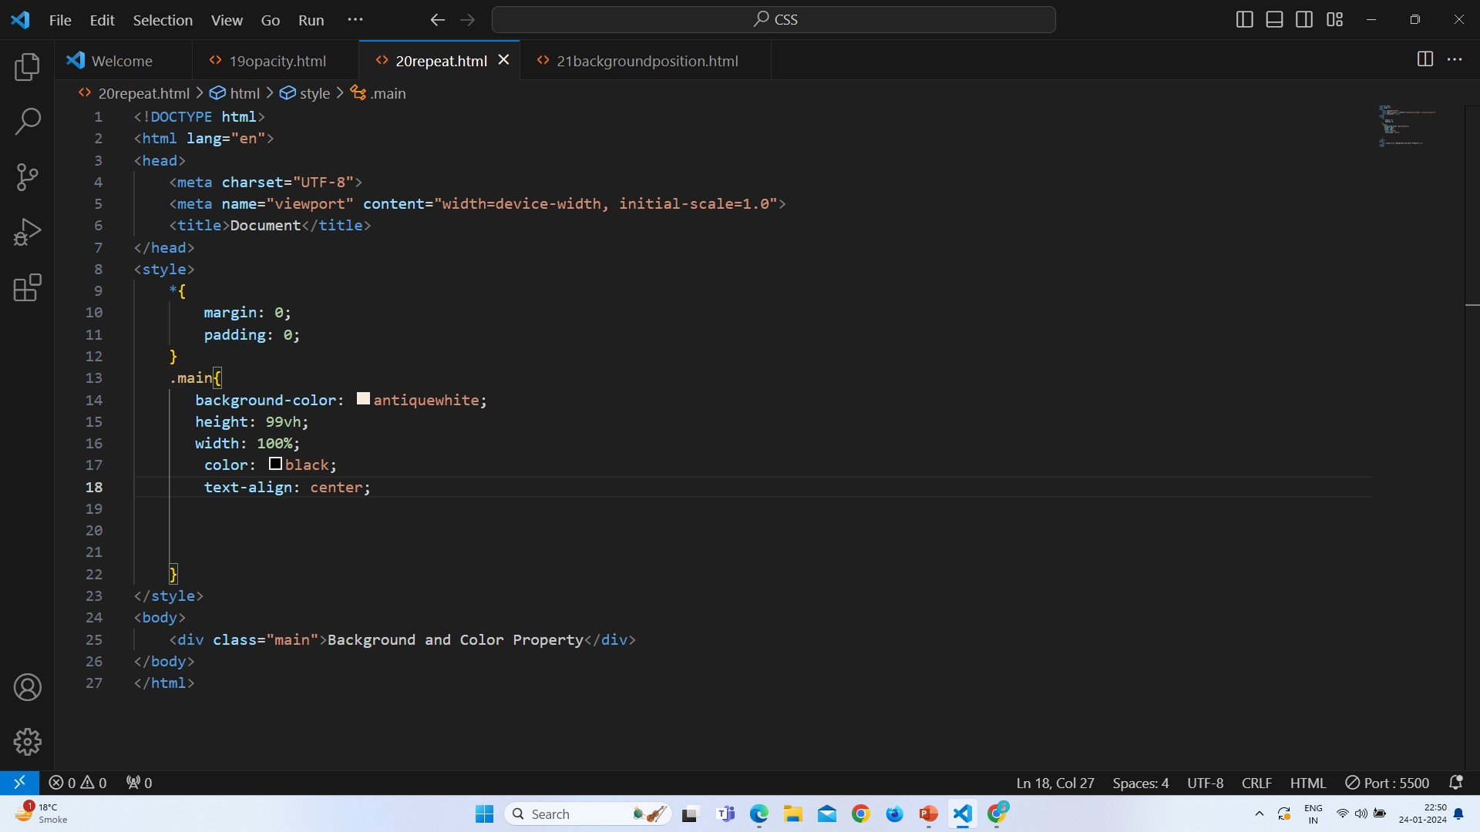
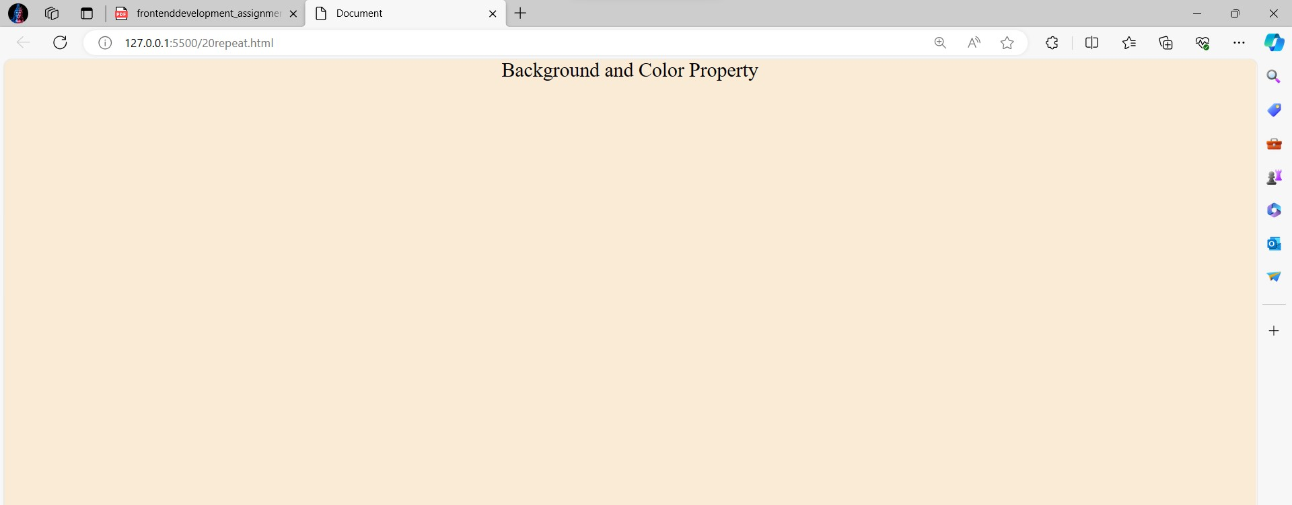
Q 12}How to maintain the CSS specifications?
Ans: To maintain the CSS specifications write a comment in your code to understand easily
Create a Responsive design of your website to make it easy for every screen.
You have to stay updated with all new CSS specifications.
To maintain the CSS specifications control your version.
World Wide Web is maintain the CSS specifications.
Q 13}What are the ways to integrate CSS as a web page? Ans: There are three ways to integrate css in a web page
1.Inline:
In this type you can write the css in the Html line
Example:
<h1 style="color: red">Test Headline</h1>
2.Internal
In internal css we can add the CSS after head.
Example:-
<html>
<head>
</head>
<style>
.main{background-color: antiquewhite;
height: 99vh;
width: 100%;
color: black;
text-align: center;
} </style>
<body>
<div class="main">Background and Color Property</div>
</body> </html>
3.External
External CSS is used to write a css in other file and link that file in html file.
Example:-
<head>
<link rel="stylesheet" type="text/css" href="index.css">
</head>
<body>
<h1> Test Headline </h1> </body>
Q 14}What is embedded style sheets?
Ans:
Embedded style sheets is exactly the same as other CSS code.
It write after a head.
Example:
<html>
<head>
</head>
<style> p{ background – color : red;
} </style>
<body>
<p>hello</p>
</body>
</html>
Q 15}What are the external style sheets?
Ans: External CSS is used to write a css in other file and link that file in html file.
Example:-
<head>
<link rel="stylesheet" type="text/css" href="index.css">
</head>
<body>
<h1> Test Headline </h1> </body>
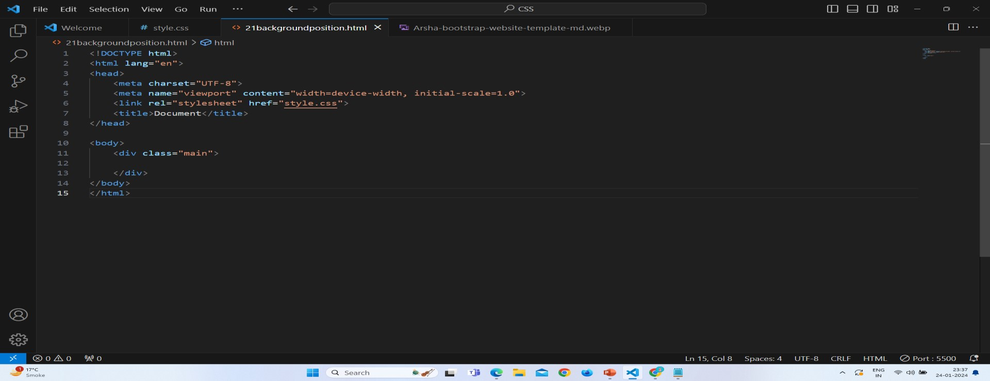
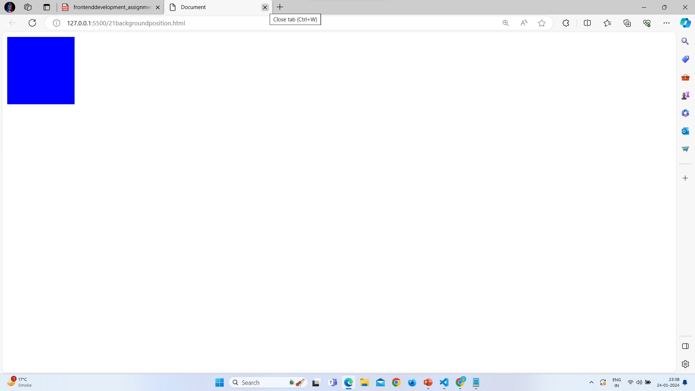
Q 16}What are the advantages and disadvantages of using external style sheets?
Ans:
Advantages of External CSS:
External CSS is easy to maintain.
This is Organize the code.
It can used to reuse in multiple HTML file.
External CSS load the page fast.
Disadvantages of External CSS:
Pages can not run correctly when the external css is not load.
External css file take a large space.
If not link a CSS file in HTML there will not show the style in your page.
Q 17}What is the meaning of the CSS selector?
Ans: CSS selector is used to find the element which was you want to style in HTML.
Selectors you can use in CSS.
Name , ID , Class
Attribute or Attribute value
Selectors you can use with:
Id is used with (#).
Class is used with (.)
Element and class (Element .Class)
For all element (*)
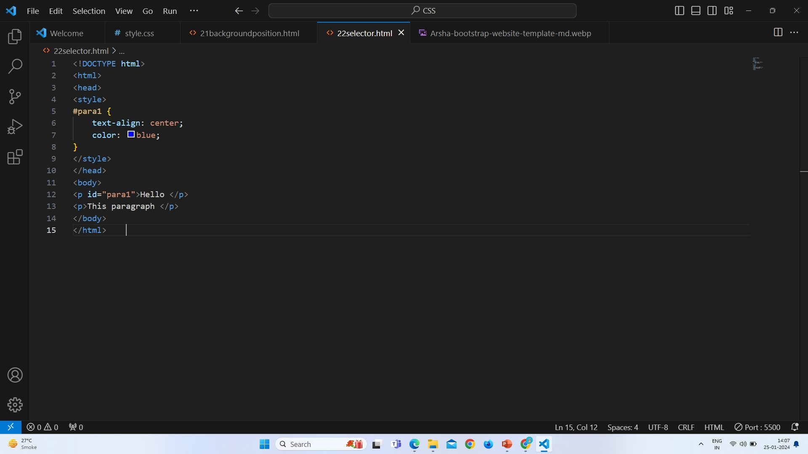
- Id selector:
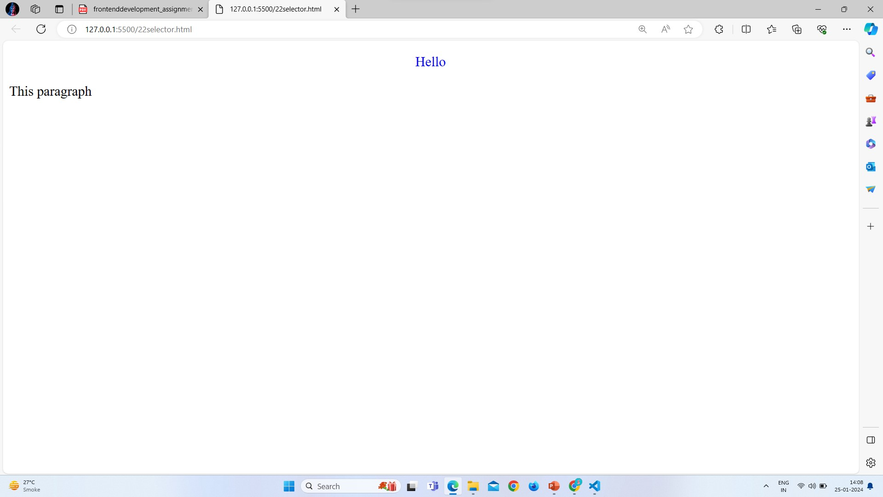
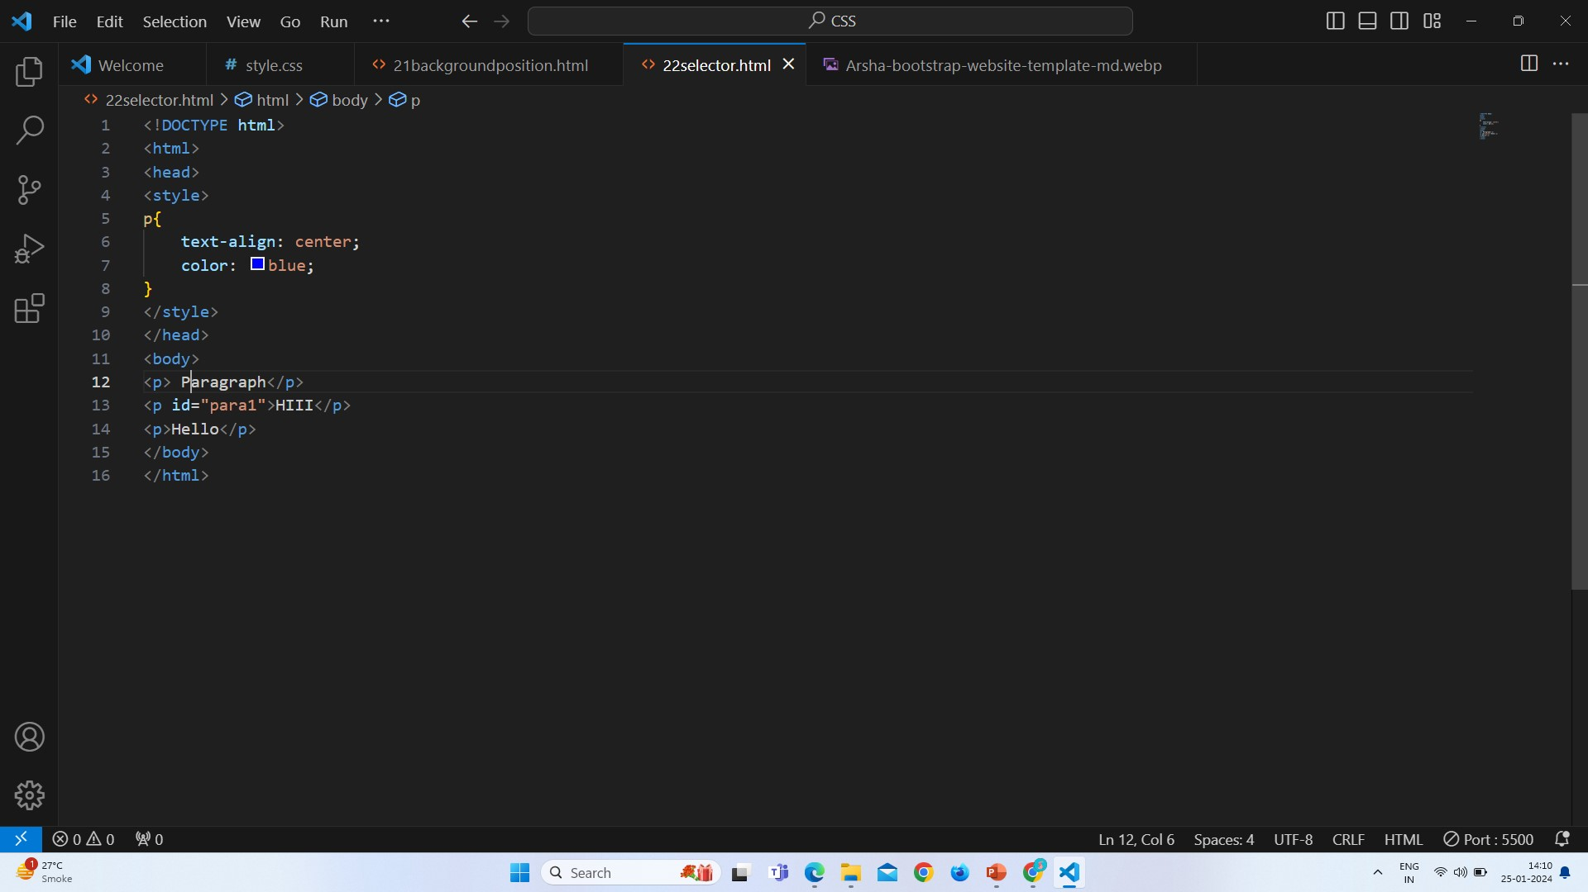
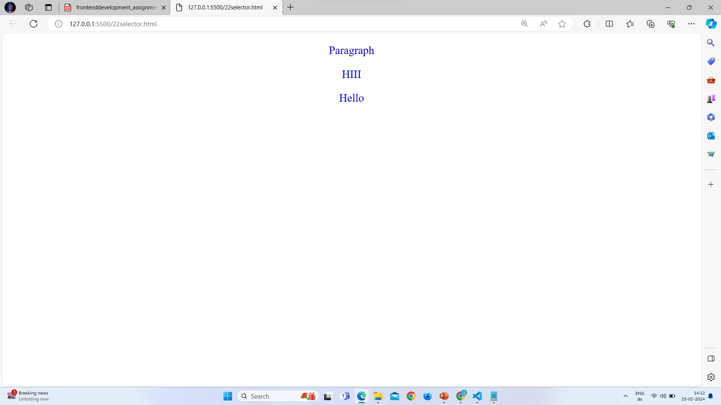
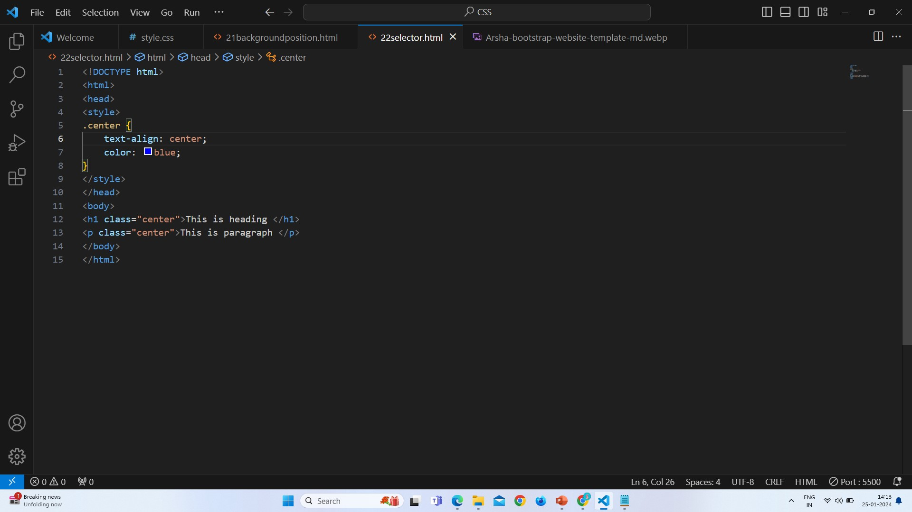
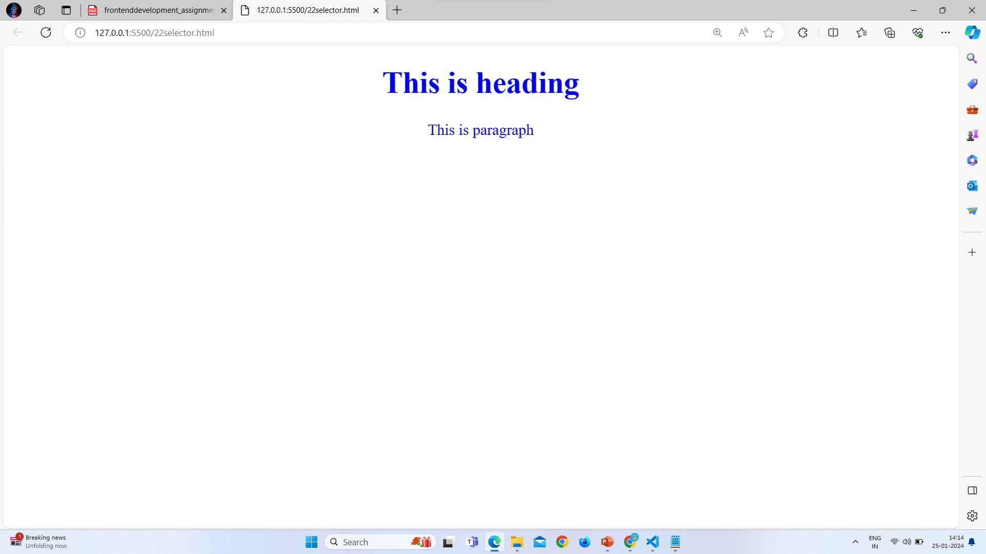
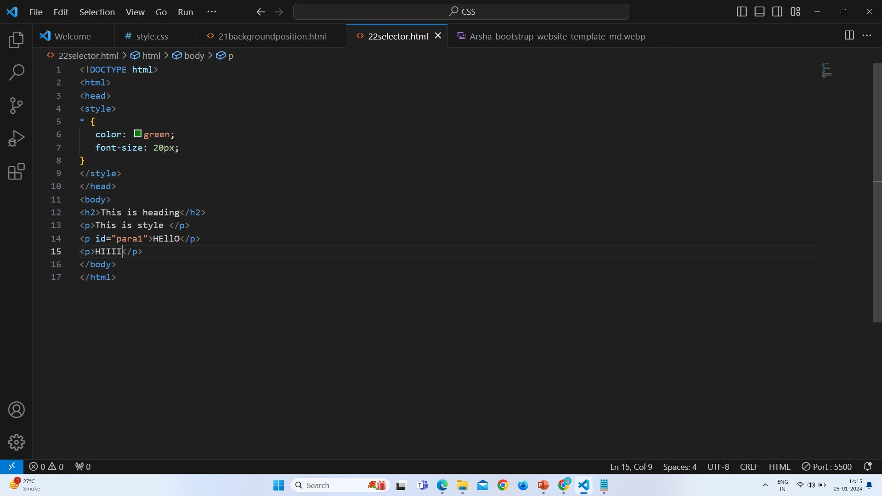
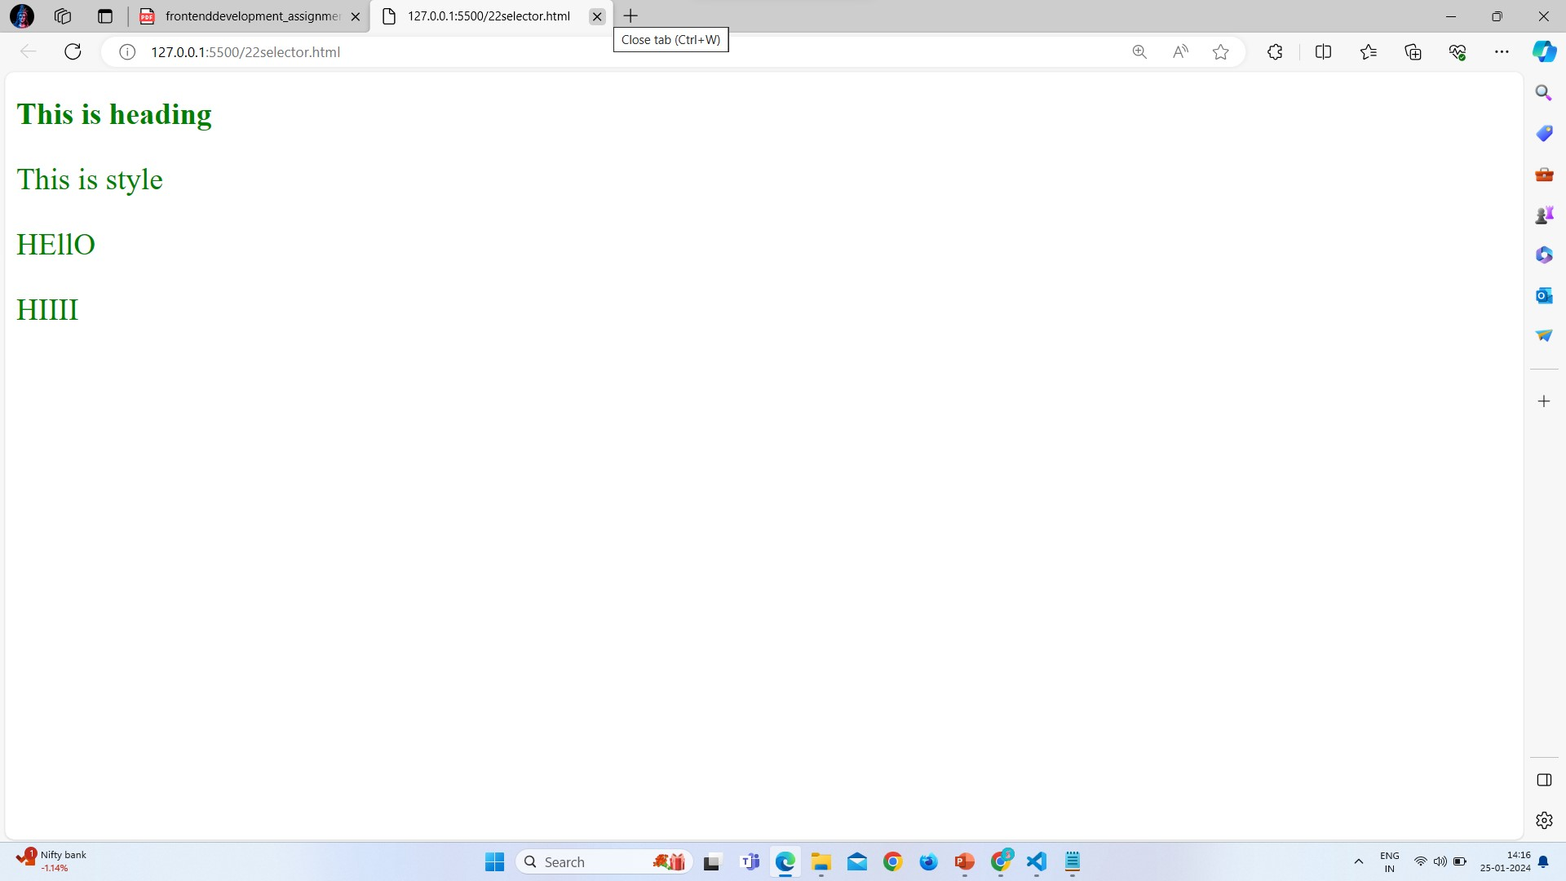
Q 18}What are the media types allowed by CSS? Ans: There are many media types used in CSS.
All:
There are all types of devices used in CSS.
TV:
CSS allowed Television type media.
Screen:
It also allow the Computer Screen.
Print:
It is used for Printers.
Projection:
Used in Projection Presentation.
Small:
Used in all small devices like Phone , Tablet etc.
Q 19}What is the rule set?
Ans: Rule set means in css there are a rule to write the CSS in format.
If you don’t write the CSS in right format that will not work.
Example:
Selector Property Value

div { color : red ; }
Property Name Declaration Block

